Key Scientific Products
1113 East Reynolds St.
Stamford, Texas 79553
SAFETY DATA SHEET
1: IDENTIFICATION
Catalog Number/Product Name: MULTIPLE
K1945 ALN L-alanyl-Lalanyl-B-naphtylamide
K9083B ARG L-arginine B-naphtylamide
K9161B CHY N-glutaryl-gly-gly-phe-B-naphtylamide (Chymotrypsin)
K9595B CYST L-cystine-DI-B-naphtylamide
K9265B GLU- AMP Glutamic acid-B-naphtylamide
K9305B GLY Glycine B-naphtylamide
K1378B LAP L-leucine B-napthylamide
K9376B LGY Leucyl-Glycine B-naphtylamide
K9525B PAL L-phenylalanine B-naphtylamide
K1532B PRO L-proline B-naphtylamide
K1538B PYR L-pyroglutamic Acid B-naphtylamide
K9575B SER L-serine B-naphtylamide
K9162B, K1084 TRY Na-Benzoyl-DL Arginine B-naphtylamide (Trypsin)
K1083 ARG L-arginine a-naphtylamide
K1305 GLY Glycine a-naphtylamide
K1376 LGY Leucyl-Glycine a-naphtylamide
K1525 PAL L-phenylalanine a-naphtylamide
K1535 PRO L-proline a-naphtylamide
K1536 PYR L-pyroglutamic acid a-naphtylamide
K1575 SER L-serine a-naphtylamide
These substrates are also listed in the following multitest tablets:
K1238, K1237, K1466

Other Common Names:
K9083B, K1083 Arginine
K9161B Chymotrypsin
K9595B Cystine
K9305B, K1305 Glycine
K9162B Trypsin
K1238 AFU/MAGA/ARG
K1237 AFU/MAGA/CHY
K1466 NAG/MBGA/TRY

Recommended Use/Restrictions: For in-vitro diagnostic use only by trained professionals.

Manufacturer/Supplier:
Key Scientific Products Phone Number: 1-800-843-1539
1113 East Reynolds Street Emergency Phone Number: None available.
Stamford, TX 79553

2: HAZARD(S) IDENTIFICATION
(a) Classification of the chemical: Carcinogenicity (Category 2), H351
(b) Signal word: WARNING

(c) Hazard statement(s): Suspected of causing cancer. Applies to rehydrated, positive reactive product only.
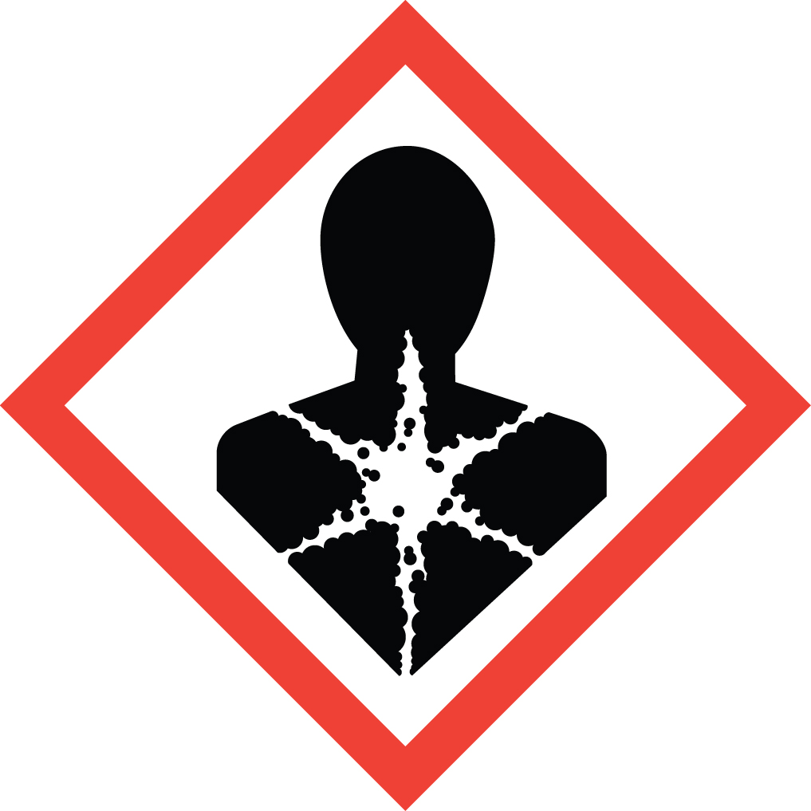
- (d) Pictogram(s):

(e) Precautionary statement(s): Store in original container. Follow directions on label and technical insert.

(f) Describe any hazards not otherwise classified that have been identified during the classification process: None
3: COMPOSITION/ INFORMATION ON INGREDIENTS
Chemical Name | Common Name/Synonym | CAS Number | Concentration (%)
L-alanyl-Lalanyl-B-naphtylamide | ALN | 39537-23-0 | <0.5 mg per substrate test
L-arginine B-naphtylamide | ARG | 18905-73-2 | “
N-glutaryl-gly-gly-phe-B-naphtylamide | CHY | 55145-12-5 | “
L-cystine-DI-B-naphtylamide | CYST | 1259-69-4 | “
Glutamic acid-B-naphtylamide | GLU-AMP | 238-542-7 | “
Glycine B-naphtylamide | GLY | 716-94-9 | “
L-leucine B-napthylamide | LAP | 893-36-7 | “
Leucyl-Glycine a-naphtylamide | LGY | Unknown | “
L-phenylalanine a-naphtylamide | PAL | 740-57-8 | “
L-proline B-naphtylamide | PRO | 97216-16-5 | “
L-pyroglutamic Acid B-naphtylamide | PYR | 22155-91-5 | “
L-serine B-naphtylamide | SER | 888-74-4 | “
Na-Benzoyl-DL Arginine B-naphtylamide | TRY | 913-04-2 | “

4: FIRST-AID MEASURES
(a) Routes of Exposure:
Eyes: In case of contact with eyes, rinse immediately with water for 10 – 15 minutes. If irritation develops and persists seek medical advice.

Ingestion: Wash large amounts of water. Seek medical attention.

Inhalation: Not Applicable. No vapors.

Skin: Wash thoroughly with soap and water. Seek medical attention if irritation occurs.
(b) Important symptoms/effects(acute and delayed): No data available.
(c) Indication of immediate medical attention and special treatment needed: No data available.

5: FIRE-FIGHTING MEASURES
(a) Suitable (and unsuitable) extinguishing media: Use water spray, CO2, foam or dry powder as the extinguisher medium.
(b) Specific hazards arising from the chemical: Carbon oxides, nitrogen oxides (NOx), HCL Gas.
(c) Special protective equipment and precautions for fire-fighters: Wear self-contained breathing apparatus if necessary.

6: ACCIDENTAL RELEASE MEASURES
(a) Personal precautions, protective equipment, and emergency procedures: Wear lab coat, gloves and safety glasses.
(b) Methods and materials for containment and cleaning up: Sweep or vacuum uninoculated product and discard as routine waste.
Inoculated tests should be treated according to accepted procedures for bacteriological hazards.

7: HANDLING AND STORAGE
(a) Precautions for safe handling: Wear appropriate PPE (gloves, lab coat, safety glasses)
(b) Conditions for safe storage: Store at 2 – 8 C in a dry atmosphere in the sealed container provided.

8: EXPOSURE CONTROLS / PERSONAL PROTECTION
(a) OSHA permissible exposure limit (PEL), American Conference of Governmental Industrial Hygienists (ACGIH) Threshold Limit Value (TLV), and any other exposure limit used or recommended by the chemical manufacturer, importer, or employer preparing the safety data sheet, where available. No exposure limits available.
(b) Appropriate engineering controls: Handle in accordance with good industrial hygiene and safety practices. Wash hands before breaks and at the end of the workday.
(c) Individual protection measures, such as personal protective equipment:
Eye Contact: Use appropriate safety glasses.

Ingestion: Drink large amounts of water. If more than 10 discs are ingested, or if a reaction occurs, consult a physician.

Inhalation: No vapors formed.

Skin Contact: Handle product with gloves. Dispose of contaminated gloves after use in accordance with applicable laws and good laboratory practices. Wash and dry hands.

9: PHYSICAL AND CHEMICAL PROPERTIES
Appearance: Physical State: Solid
Color: White disc or swab. White or gray tablet.
Odor: No data available
Odor Threshold: No data available
pH: No data available
Melting Point/Freezing Point: No data available
Boiling Point/Boiling Range: No data available
Flash Point: No data available
Evaporation Rate: No data available
Flammability: No data available
Upper and Lower Flammability/Explosive Limits: No data available
Vapor Pressure: No data available
Vapor Density: No data available
Relative Density: No data available
Solubility: Soluble in water
Partition coefficient (n-octanol/water): No data available
Auto-ignition Temperature: No data available
Decomposition Temperature: No data available
Viscosity: No data available

10: STABILITY AND REACTIVITY
(a) Reactivity: Non reactive

(b) Chemical stability: The product is stable

(c) Possibility of hazardous reactions: No data available

(d) Conditions to avoid (e.g., static discharge, shock, or vibration): No data available

(e) Incompatible materials: Oxidizing agents

(f) Hazardous decomposition products: No data available. In the event of a fire, see Section 5.
11: TOXICOLOGICAL INFORMATION
Description of the various toxicological (health) effects and the available data used to identify those effects, including:
(a) Information on the likely routes of exposure (inhalation, ingestion, skin and eye contact): No data available

(b) Symptoms related to the physical, chemical and toxicological characteristics: No data available

(c) Delayed and immediate effects and also chronic effects from short- and long-term exposure: No data available

(d) Numerical measures of toxicity (such as acute toxicity estimates): No data available

(e) Whether the hazardous chemical is listed in the National Toxicology Program (NTP) Report on Carcinogens (latest edition) or has been found to be a potential carcinogen in the International Agency for Research on Cancer (IARC) Monographs (latest edition), or by OSHA:
Limited evidence of carcinogenicity in animal studies. While unbound naphtylamide is a possible carcinogen, the unbound state is present only in a positive test, and each test contains less than 0.5 mg of the substrate.
12: ECOLOGOICAL INFORMATION
Toxicity: No data available
Results of PBT & vPvB assessment: PBT/vPvB assessment not available since chemical safety assessment not required/not conducted.
Persistance & degradability: No data available
Mobility in soil: No data available
Bioaccumulative potential: No data available
Other adverse effects: No data available
13: DISPOSAL CONSIDERATIONS
Waste Disposal: Uninoculated discs, swabs or tablets may be discarded as normal waste. Inoculated waste should be discarded in a manner appropriate for biological hazards.
14: TRANSPORT INFORMATION
DOT Hazard Class: Not dangerous goods
Shipping Name: Not dangerous goods
Identification Number: Not dangerous goods
Packing Group: Not dangerous goods
15: REGULATORY INFORMATION
Carcinogenicity: YES / NO
NTP: No
IARC: No
OSHA: No
California Prop 65: No
IATA: No
16: OTHER INFORMATION
The above information, to the best of our knowledge, is accurate. Key Scientific Products assumes no liability whatsoever for the accuracy or completeness of the information stated above. Final determination of suitability of any material is the sole responsibility of the user. All materials may present unknown hazards and should be used with caution. Although certain hazards may be described, we cannot guarantee that these are the only hazards that exist.

Revision Date: May 2016

